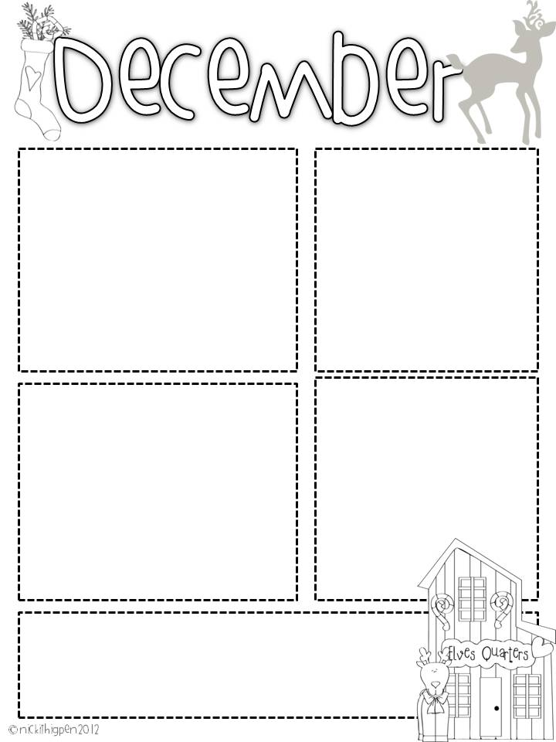

**Flat Stanley**

Some of our Flat Stanley’s are coming back in. If your child hasn’t received theirs yet you might ask the person we mailed him to if they could send him back in. We are working on our map unit and would love to know about other places.

**Winter Party**

Our winter party will be on Thursday December 20th at 2:00pm. Please feel free to join in our celebration! We are getting ready with books for the book exchange and supplies that are needed to make our celebration great! We have 23 students in our class. Thanks for all of your help with this event. We couldn’t do it without you! Feel free to send in items at any time but I wanted to give you plenty of shopping time! Other items and snacks are welcome too!

**Dates to remember:**

December 4th -Scholastic Order Due (Books for Book Exchange)

December 18th Please send in all items for our party both books and snacks so I will know what I need to pick up before our party.

December 19th PJ and Polar Express Day

December 20th Winter Party/**Book Exchange** 2:00 pm **Please email me if you have any questions or are unable to participate.**

December 21st -January 2nd Winter Break No School

January 3rd- Back to School

**Words to practice**

Sight Words: **just, every**

**Please keep working on**:

**will, new, then, all, her, out, do, say, of, fly, eat, let, went, had, an, his, that, could, are, walk, when, white, this, ask, stop, live, old, going, but, open, she, any, ate, came, too, with, there, again, by**

Students will be tested over the spelling words and sight words each Friday.

If you have any questions about the **book exchange** please contact me at [dbounds@prs.k12.ar.us](mailto:dbounds@prs.k12.ar.us)or send a note in your child’s folder.

**Chap Stick**

Now that the weather is cooler we are getting chapped lips. If you would like to send a chap stick to school in your child’s backpack they can use it when we come in from recess. It will have to stay in their backpack and be returned to it directly after use. I hope this can cut down on our lips stinging in the winter months.

**What we are learning**

This week we will start our book study “We are Wonders”. This book is about showing kindness to others and that we are all special even though we are different. In our unit study, we will be learning about continents and this week our focus is on North and South America. In math, we are reviewing 3D shapes talking about fractions and starting to learn about the clock. We are starting report card assessments this week too. Please keep reading at home, this will help tremendously!

Mrs. Bounds’ Class December 4th