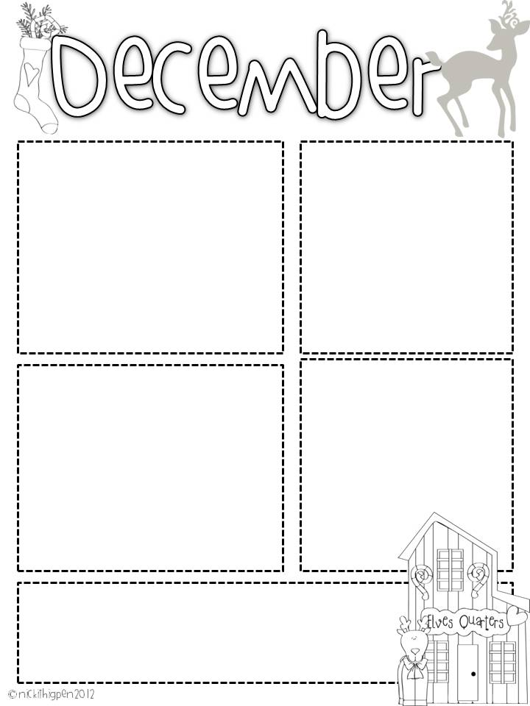

**Ten Marks**

We have been using an app called tenmarks. I am sending home a log in page so that your child can use it at home too. It can be on a computer, phone, or tablet. The questions are often a worded a little harder than what we do in class. But it will help when we take our standardized state testing. Keep practicing over the winter break! Thanks

**What we are learning**

In our unit study, we will be finishing up continents and this week our focus is on Christmas around the world. In math, we are reviewing the clock, and adding coins, and doing a fun Santa Shape project. We will also be comparing the book and the movie of Polar Express. We will be making some crafts for Christmas as gifts!

If you need anything, please contact me at [dbounds@prs.k12.ar.us](mailto:dbounds@prs.k12.ar.us) or send a note in your child’s folder.

**Dates to remember:**

**Please send in your books tomorrow for our book exchange!**

December 20th at 2pm

Winter Party/Book Exchange

December 20th Pajama Day Tops and Bottoms and No slippers please!

December 21st -January 2nd Winter Break

January 3rd First Day back after break

**Lost and Found**

If you have lost items, please have your child stop and look for them in the lost and found. You can stop by too. There are many lunch boxes, jackets and other things to be found. =)

**Words to practice**

Sight Words: **get, were**

**Please keep working on**:

**will, new, then, all, her, out, do, say, of, fly, eat, let, went, had, an, his, that, could, are, walk, when, white, this, ask, stop, live, old, going, but, open, she, any, ate, came, too, with, there, again, by, just, every**

**We will not have a sight word or spelling test this week. Please keep reviewing the old words!**

Mrs. Bounds’ Class December 15th

**Reading over Break**

Please remember to read over the Christmas break. At this age the students quickly forget what they have learned.

There are guided reading books in their folders and the December writing page they can work on over the break. Thanks

Mrs. Bounds

Hope that you all have a wonderful Christmas and a Happy New Year!!