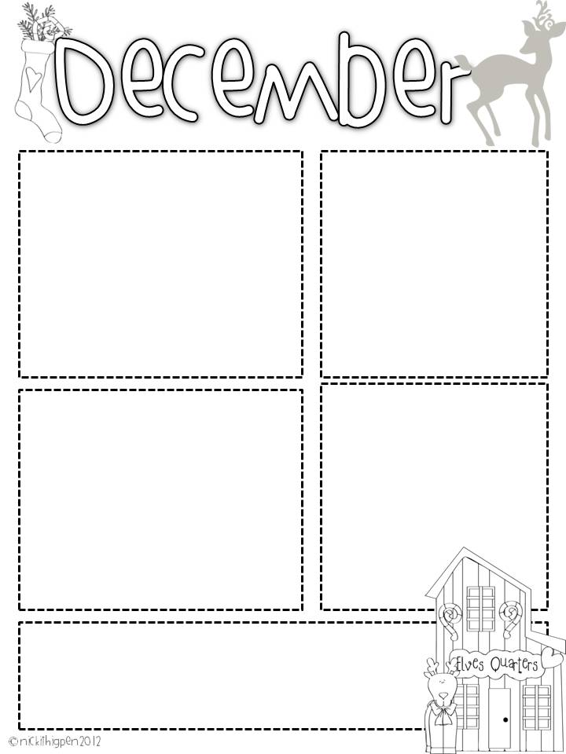

**Christmas Party**

Feel free to send in items at any time. Other goodies and snacks are welcome too!

**Words to practice**

Sight Words: **get, were**

**Please keep working on**:

**will, new, then, all, her, out, do, say, of, fly, eat, let, went, had, an, his, that, could, are, walk, when, white, this, ask, stop, live, old, going, but, open, she, any, ate, came, too, with, there, again, by, just, every**

**Yes, we will still have sight word and spelling tests this week!**

If you need anything, please contact me at [dbounds@prs.k12.ar.us](mailto:dbounds@prs.k12.ar.us) or send a note in your child’s folder.

**Writing over the Christmas Break**

The writing page that was sent home today is also to be done over Christmas break. Choose at least 6 items to write about and return them with the paper after the break. Students can choose something out of our reward catalog too! Thanks for your help!

**Homework** Acts of Kindness

There was a paper with a Santa beard that was sent home last week. If you child does one thing each day and then cut if off. When it is returned after the break they can choose something out of our reward catalog. I hope that your kids are showing kindness like Auggie from our book ***Wonder***!

**Dates to remember:**

December 18th Please send in all items for our party both books and snacks so I will know what I need to pick up before our party.

December 20th Pajama Day Tops and Bottoms and No slippers please!

December 20th Winter Party/**Book Exchange** 2:00 pm **Please email me if you have any questions or are unable to participate.**

December 21st -January 2nd Winter Break

**No School. Return to school on Jan 3rd!**

Mrs. Bounds’ Class December 11th

**What we are learning**

In our unit study, we will be learning about continents and this week our focus is on Africa, Europe, Asia, Antarctica, and Australia. In math, we are reviewing the clock, addition and subtraction problems, and adding coins. In literacy, we are working on punctuation, adding details in our writing, and grammar.